Sample: DB5, Carolina bay outer basin

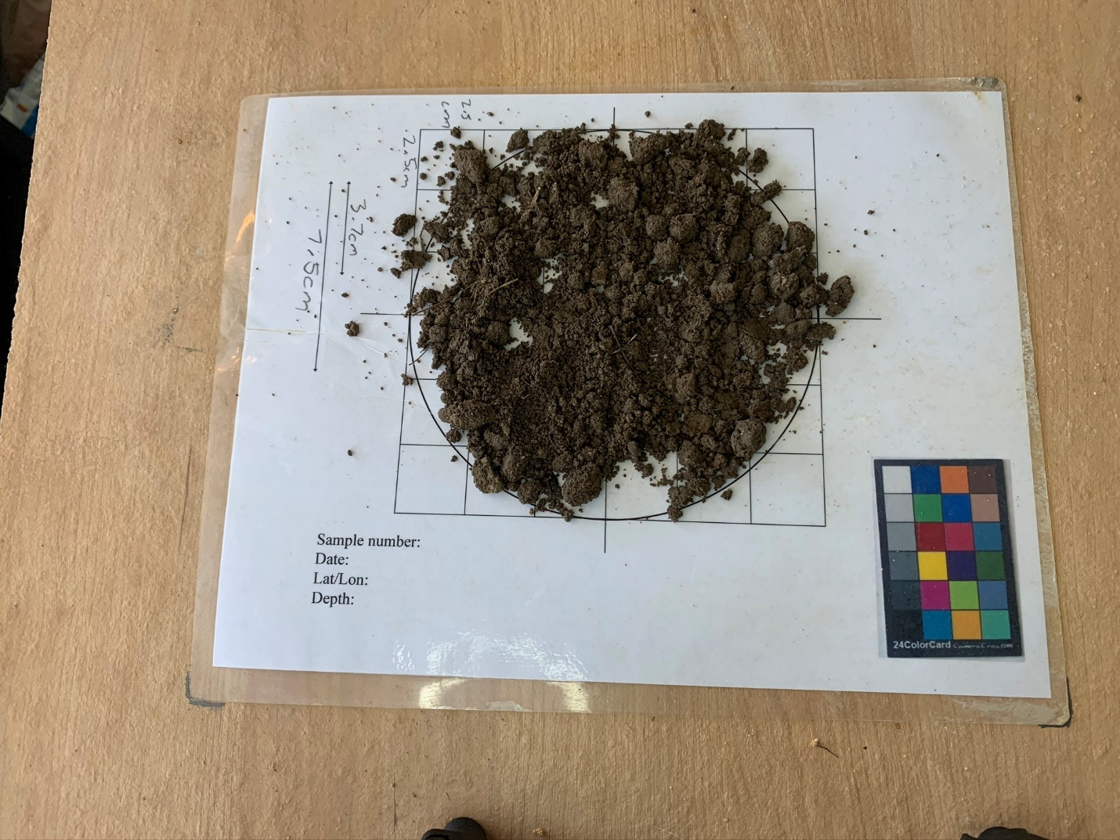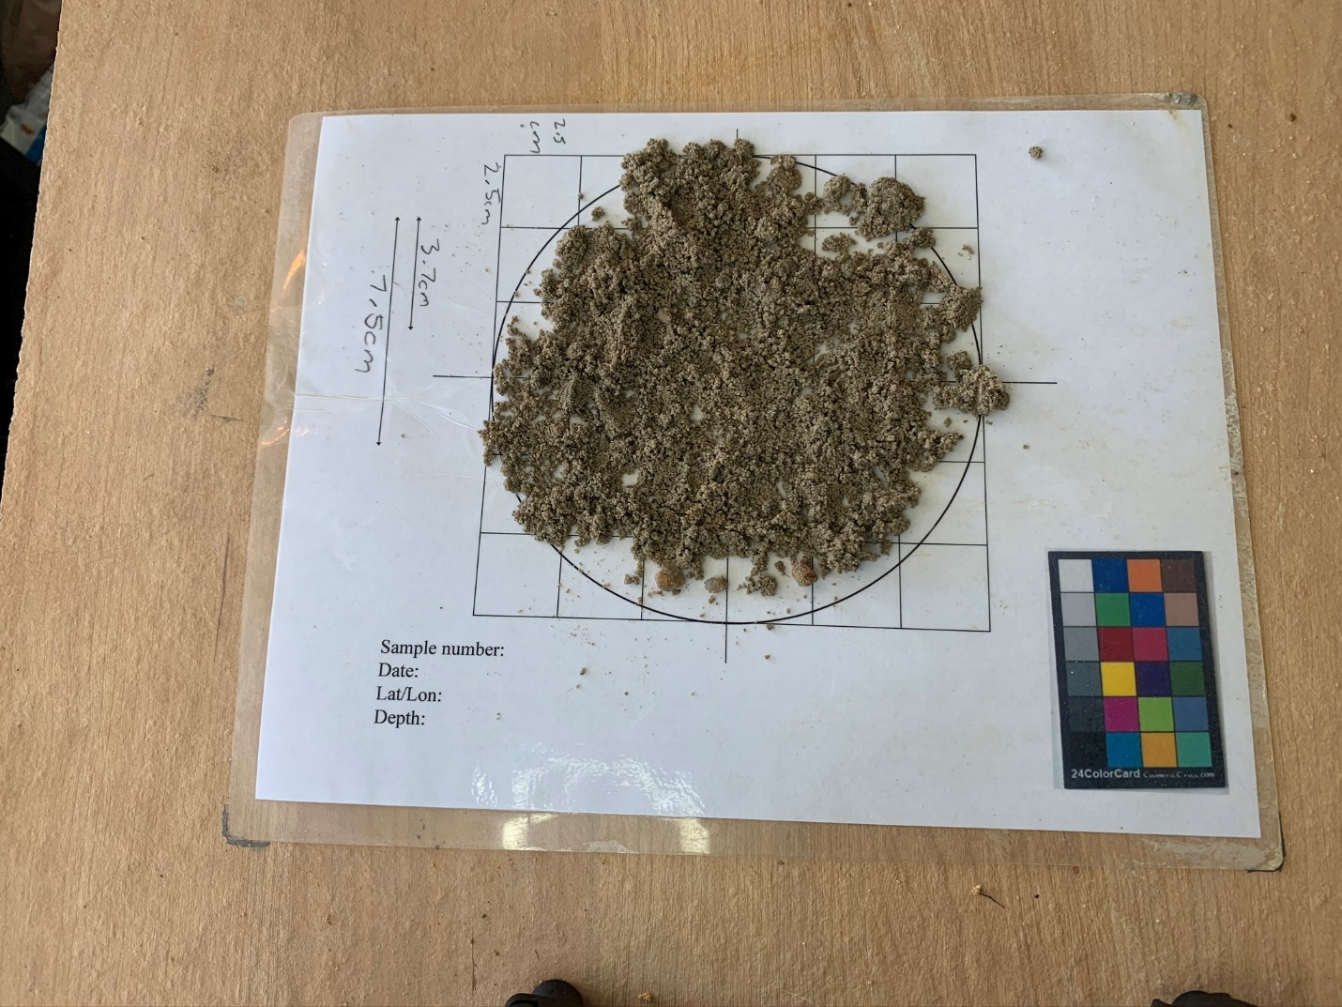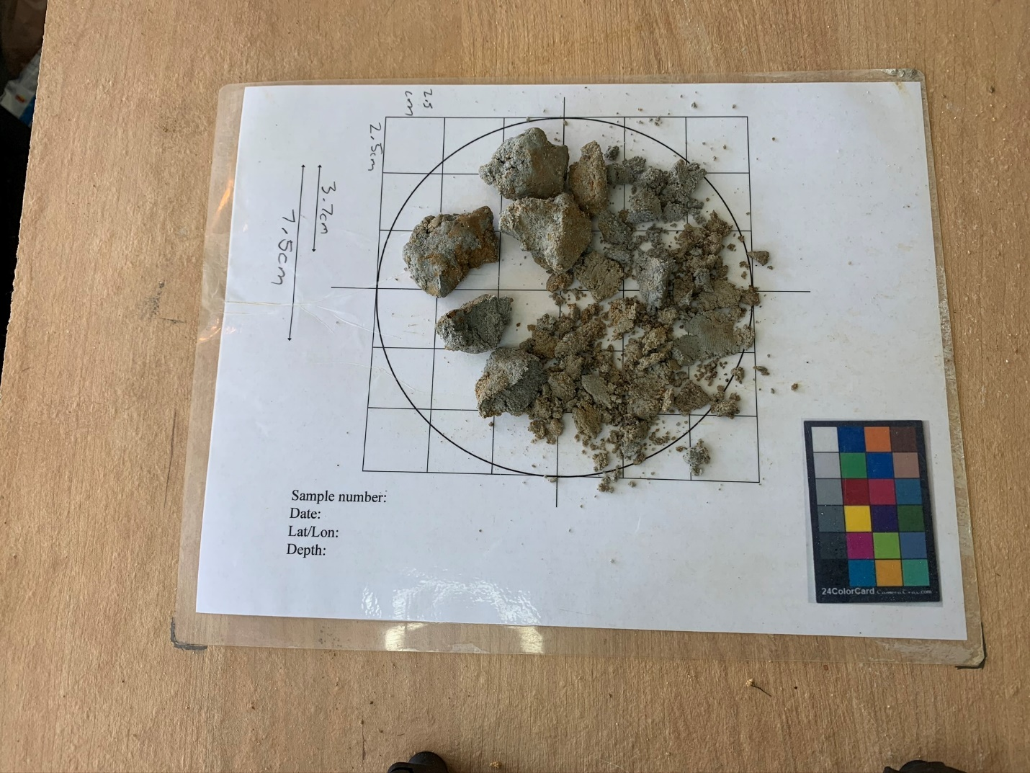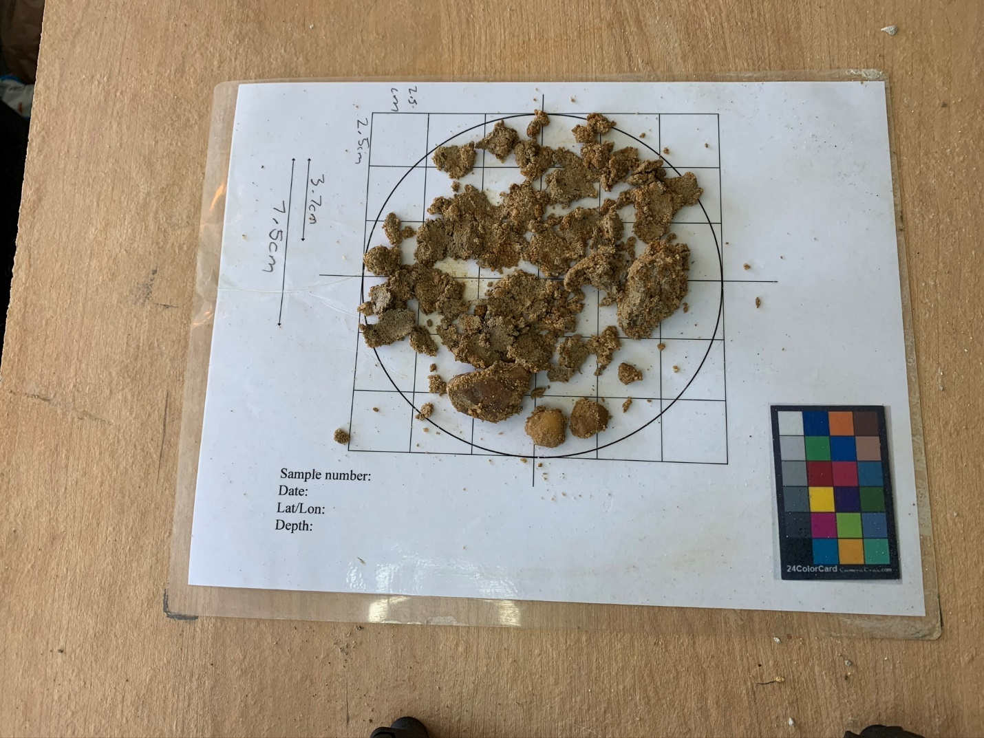

|  |  |
| --- | --- |
| 0cm – 20cm | Organic rich soil |
| 20cm – 43cm | Very fine, fine, medium, and coarse sand with some clay and silt, grayish brown color |
| 43cm – 69cm | Fine, medium, and coarse sand with pebbles near bottom off section, light gray with some orange coloring |
| 69cm – 137 cm | Stiff, silty, sandy clay, light gray with some orange coloring |
| 137cm – 155cm | Medium to coarse to very coarse sand with gravel, light gray to light brown with orange coloring, likely Columbia Formation. |